**Hello World RESTful Web Service**

**SpringLearnApplication.java**

package com.cognizant.springlearn;

import org.springframework.boot.SpringApplication;

import org.springframework.boot.autoconfigure.SpringBootApplication;

import org.springframework.context.ApplicationContext;

import org.springframework.context.support.ClassPathXmlApplicationContext;

import org.springframework.boot.WebApplicationType;

import org.springframework.boot.WebApplicationType;

import java.text.SimpleDateFormat;

import java.util.Date;

@SpringBootApplication

public class SpringLearnApplication {

public static void main(String[] args) {

SpringApplication.run(SpringLearnApplication.class, args);

System.out.println("Spring Boot application started");

displayDate();

}

public static void displayDate() {

ApplicationContext context = new ClassPathXmlApplicationContext("date-format.xml");

SimpleDateFormat format = context.getBean("dateFormat", SimpleDateFormat.class);

try {

Date date = format.parse("31/12/2018");

System.out.println("Parsed Date: " + date);

} catch (Exception e) {

e.printStackTrace();

}

}

}

**HelloController.java**

package com.cognizant.springlearn.controller;

import org.slf4j.Logger;

import org.slf4j.LoggerFactory;

import org.springframework.web.bind.annotation.GetMapping;

import org.springframework.web.bind.annotation.RestController;

@RestController

public class HelloController {

private static final Logger LOGGER = LoggerFactory.getLogger(HelloController.class);

@GetMapping("/hello")

public String sayHello() {

LOGGER.info("START - sayHello()");

String message = "Hello World!!";

LOGGER.info("END - sayHello()");

return message;

}

}

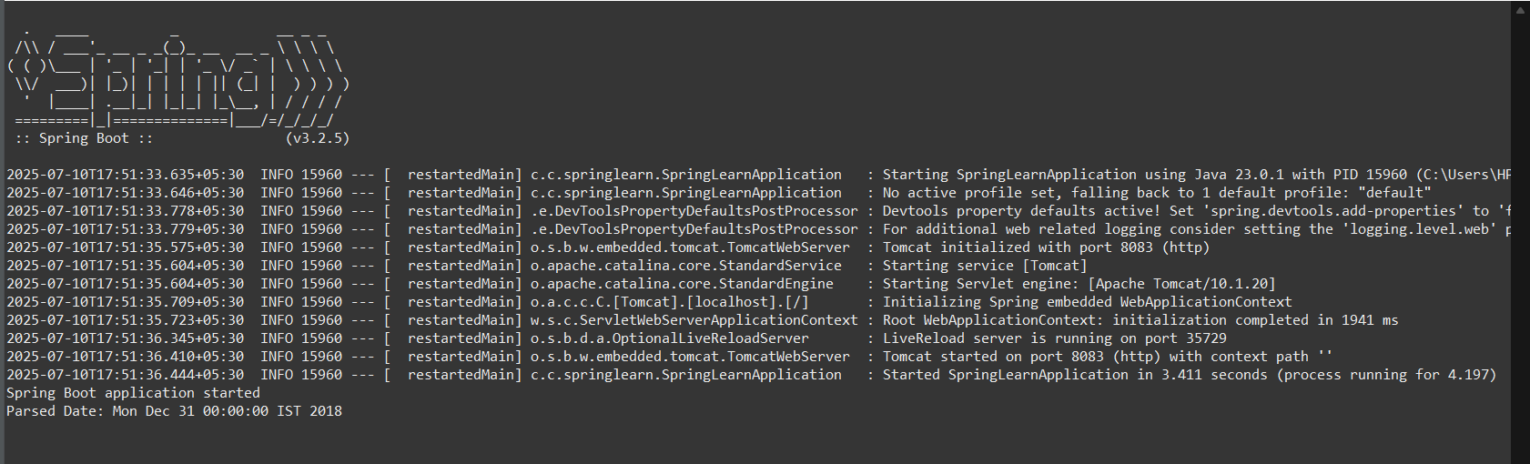



**REST - Country Web Service**

**SpringLearnApplication.java**

package com.cognizant.springlearn;

import org.springframework.boot.SpringApplication;

import org.springframework.boot.autoconfigure.SpringBootApplication;

import org.springframework.context.ApplicationContext;

import org.springframework.context.support.ClassPathXmlApplicationContext;

import org.springframework.boot.WebApplicationType;

import org.springframework.boot.WebApplicationType;

import java.text.SimpleDateFormat;

import java.util.Date;

@SpringBootApplication

public class SpringLearnApplication {

public static void main(String[] args) {

SpringApplication.run(SpringLearnApplication.class, args);

System.out.println("Spring Boot application started");

displayDate();

}

public static void displayDate() {

ApplicationContext context = new ClassPathXmlApplicationContext("date-format.xml");

SimpleDateFormat format = context.getBean("dateFormat", SimpleDateFormat.class);

try {

Date date = format.parse("31/12/2018");

System.out.println("Parsed Date: " + date);

} catch (Exception e) {

e.printStackTrace();

}

}

}

**Country.java**

package com.cognizant.springlearn.model;

public class Country {

private String code;

private String name;

public Country() {

}

public Country(String code, String name) {

this.code = code;

this.name = name;

}

public String getCode() {

return code;

}

public void setCode(String code) {

this.code = code;

}

public String getName() {

return name;

}

public void setName(String name) {

this.name = name;

}

}

**Country.xml**

<?xml version="1.0" encoding="UTF-8"?>

<beans xmlns="http://www.springframework.org/schema/beans"

xmlns:xsi="http://www.w3.org/2001/XMLSchema-instance"

xsi:schemaLocation="http://www.springframework.org/schema/beans

https://www.springframework.org/schema/beans/spring-beans.xsd">

<bean id="in" class="com.cognizant.springlearn.model.Country">

<property name="code" value="IN"/>

<property name="name" value="India"/>

</bean>

</beans>

**CountryController.java**

package com.cognizant.springlearn.controller;

import com.cognizant.springlearn.model.Country;

import org.springframework.context.ApplicationContext;

import org.springframework.context.support.ClassPathXmlApplicationContext;

import org.springframework.web.bind.annotation.RequestMapping;

import org.springframework.web.bind.annotation.RestController;

@RestController

public class CountryController {

@RequestMapping("/country")

public Country getCountryIndia() {

ApplicationContext context = new ClassPathXmlApplicationContext("country.xml");

Country country = (Country) context.getBean("in");

return country;

}

}

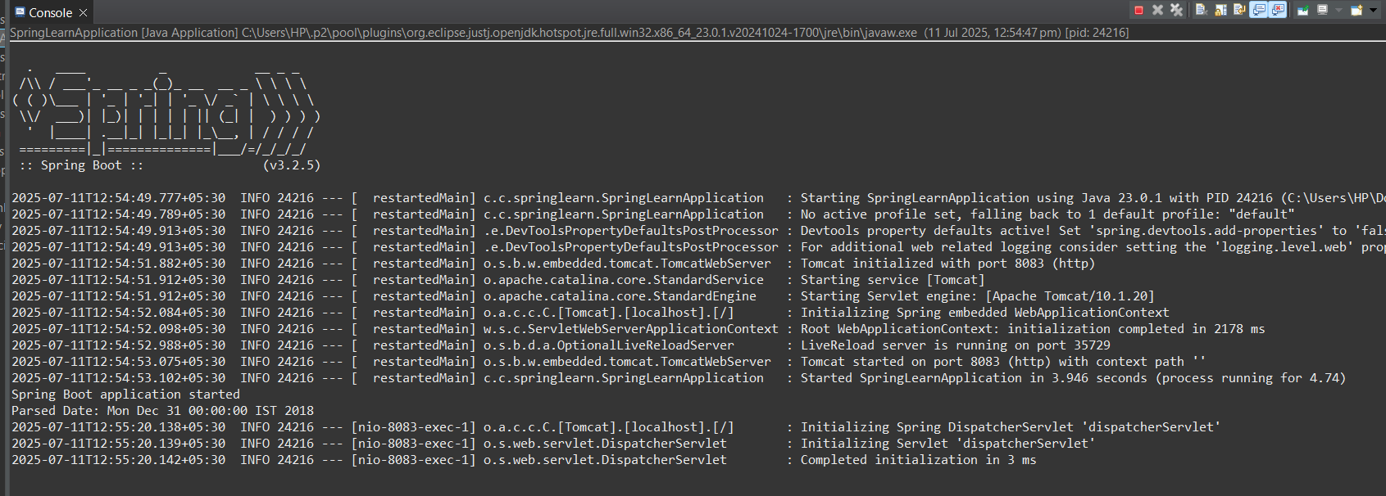

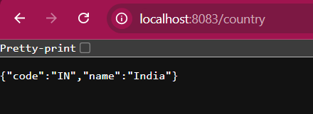

**REST - Get country based on country** code

**SpringLearnApplication.java**

package com.cognizant.springlearn;

import org.springframework.boot.SpringApplication;

import org.springframework.boot.autoconfigure.SpringBootApplication;

import org.springframework.context.ApplicationContext;

import org.springframework.context.support.ClassPathXmlApplicationContext;

import org.springframework.boot.WebApplicationType;

import org.springframework.boot.WebApplicationType;

import java.text.SimpleDateFormat;

import java.util.Date;

@SpringBootApplication

public class SpringLearnApplication {

public static void main(String[] args) {

SpringApplication.run(SpringLearnApplication.class, args);

System.out.println("Spring Boot application started");

displayDate();

}

public static void displayDate() {

ApplicationContext context = new ClassPathXmlApplicationContext("date-format.xml");

SimpleDateFormat format = context.getBean("dateFormat", SimpleDateFormat.class);

try {

Date date = format.parse("31/12/2018");

System.out.println("Parsed Date: " + date);

} catch (Exception e) {

e.printStackTrace();

}

}

}

**CountryService.java**

package com.cognizant.springlearn.service;

import com.cognizant.springlearn.model.Country;

import org.springframework.context.ApplicationContext;

import org.springframework.context.support.ClassPathXmlApplicationContext;

import org.springframework.stereotype.Service;

import java.util.List;

@Service

public class CountryService {

public Country getCountry(String code) {

ApplicationContext context = new ClassPathXmlApplicationContext("country.xml");

List<Country> countryList = context.getBean("countryList", List.class);

for (Country country : countryList) {

if (country.getCode().equalsIgnoreCase(code)) {

return country;

}

}

return null; // will add exception in next step

}

}

**CountryController.java**

package com.cognizant.springlearn.controller;

import com.cognizant.springlearn.model.Country;

import com.cognizant.springlearn.service.CountryService;

import org.springframework.web.bind.annotation.*;

@RestController

public class CountryController {

@GetMapping("/countries/{code}")

public Country getCountry(@PathVariable String code) {

CountryService service = new CountryService();

return service.getCountry(code);

}

}

**country.xml**

<?xml version="1.0" encoding="UTF-8"?>

<beans xmlns="http://www.springframework.org/schema/beans"

xmlns:xsi="http://www.w3.org/2001/XMLSchema-instance"

xsi:schemaLocation="http://www.springframework.org/schema/beans

https://www.springframework.org/schema/beans/spring-beans.xsd">

<bean id="countryList" class="java.util.ArrayList">

<constructor-arg>

<list>

<bean class="com.cognizant.springlearn.model.Country">

<property name="code" value="IN"/>

<property name="name" value="India"/>

</bean>

<bean class="com.cognizant.springlearn.model.Country">

<property name="code" value="US"/>

<property name="name" value="United States"/>

</bean>

<bean class="com.cognizant.springlearn.model.Country">

<property name="code" value="JP"/>

<property name="name" value="Japan"/>

</bean>

</list>

</constructor-arg>

</bean>

</beans>

